Core Game Engine

The initial project has been made on Unreal Engine 4 how ever, Core is a PC-based game creation tool built on top of Unreal Engine, Epic's wildly popular game engine.

https://www.coregames.com/

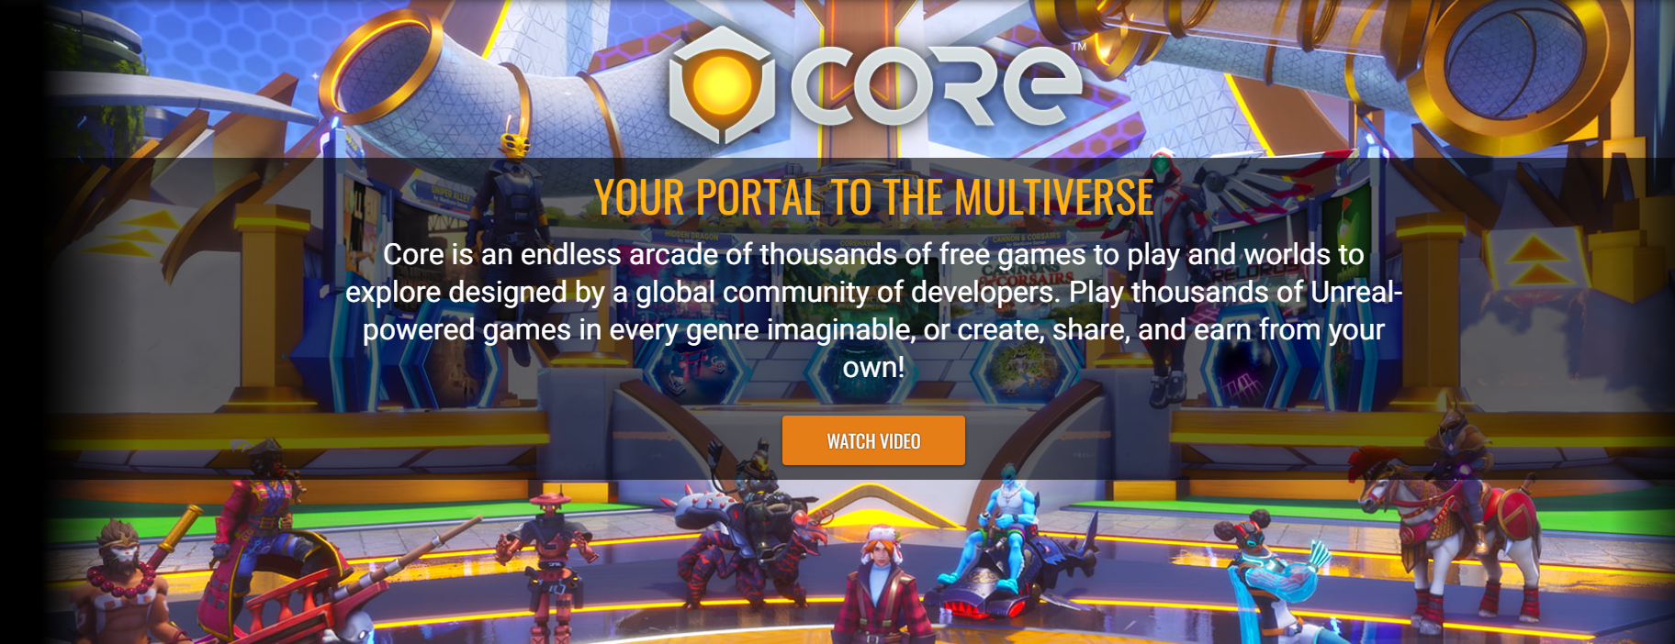

You can create a game using a large collection of premade assets and then fit them together how you want. An advantage of the Core Engine woul be the fact that got already made and resolved the server settings for multiplayer to be a reality and ready, the only trouble would be that instead of the use of blueprints graphic script would be using the programming language Lua, Lua is a powerful, efficient, lightweight, embeddable scripting language. It supports procedural programming, object-oriented programming, functional programming, data-driven programming, and data description.

Lua combines simple procedural syntax with powerful data description constructs based on associative arrays and extensible semantics. Lua is dynamically typed, runs by interpreting bytecode with a register-based virtual machine, and has automatic memory management with incremental garbage collection, making it ideal for configuration, scripting, and rapid prototyping.

Lua is designed, implemented, and maintained by a team at PUC-Rio, the Pontifical Catholic University of Rio de Janeiro in Brazil. Lua was born and raised in Tecgraf, formerly the Computer Graphics Technology Group of PUC-Rio. Lua is now housed at LabLua, a laboratory of the Department of Computer Science of PUC-Rio.
Multiple Games have been using the language for multiple settings.

https://en.wikipedia.org/wiki/Category:Lua_(programming_language)-scripted_video_games

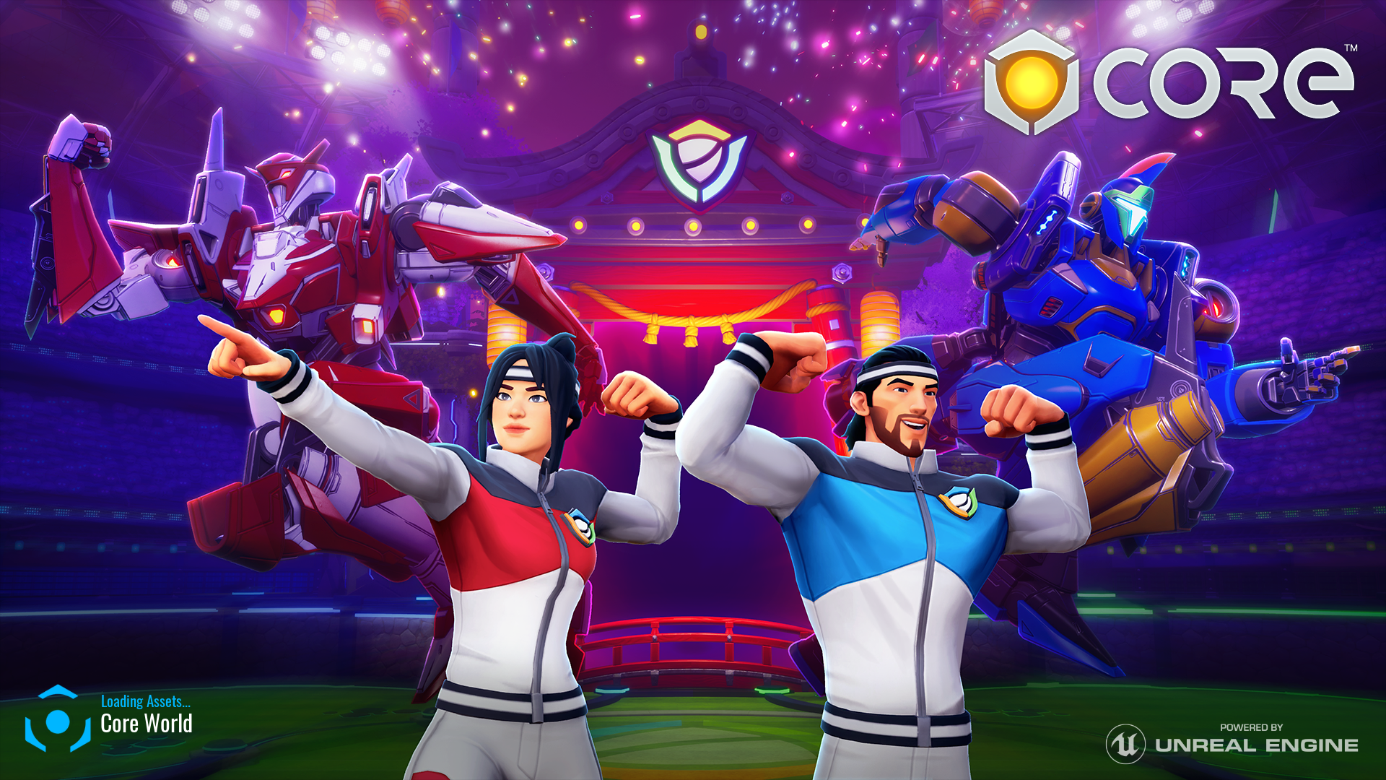

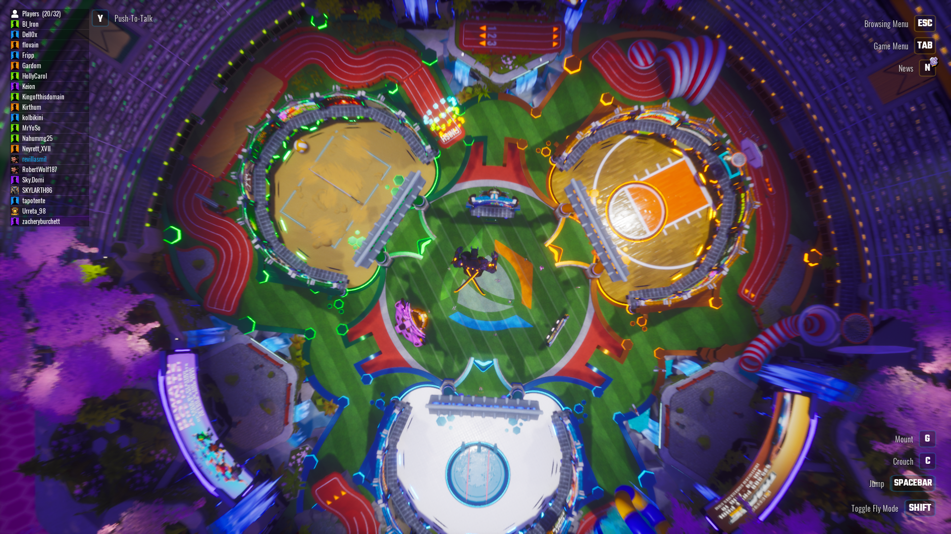

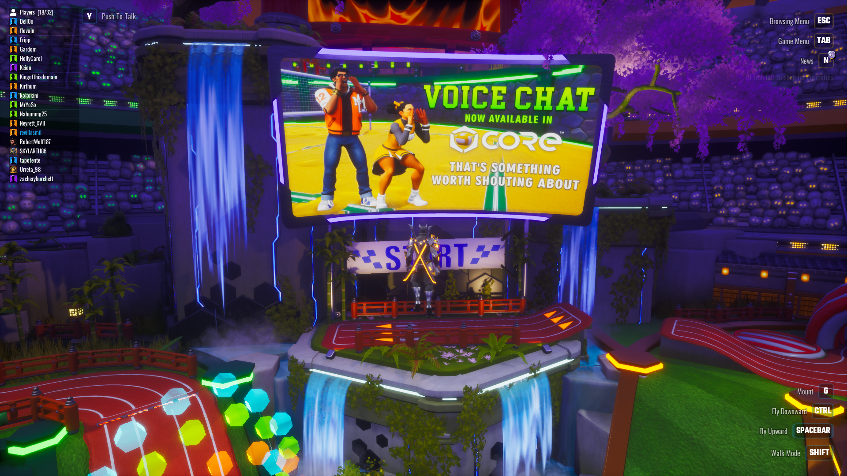
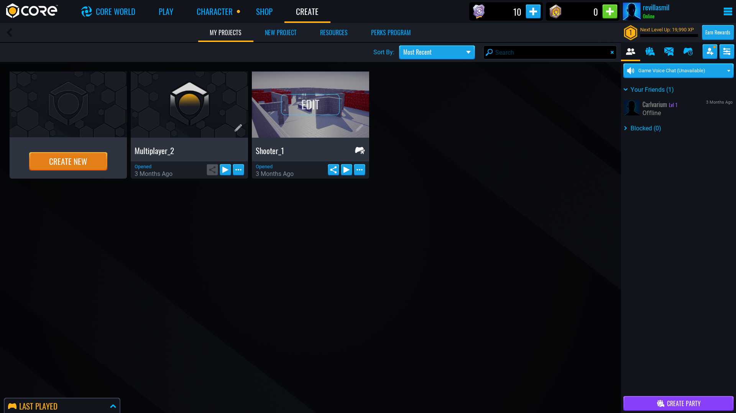

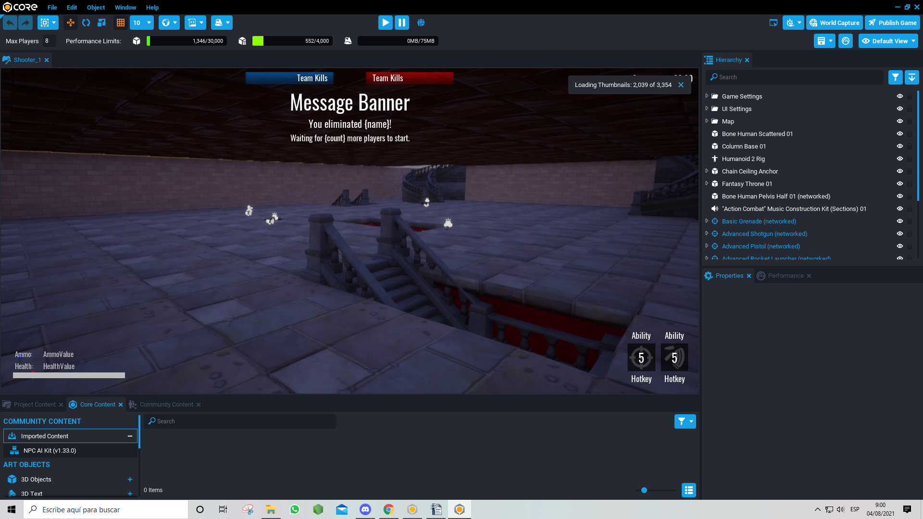

The Core Engine inlcudes multiple templates for basics multiplayer games to save time and to take care on making a few changes regarding the logic and functions as well to add a few customs scripts and settings from the creator preferences.

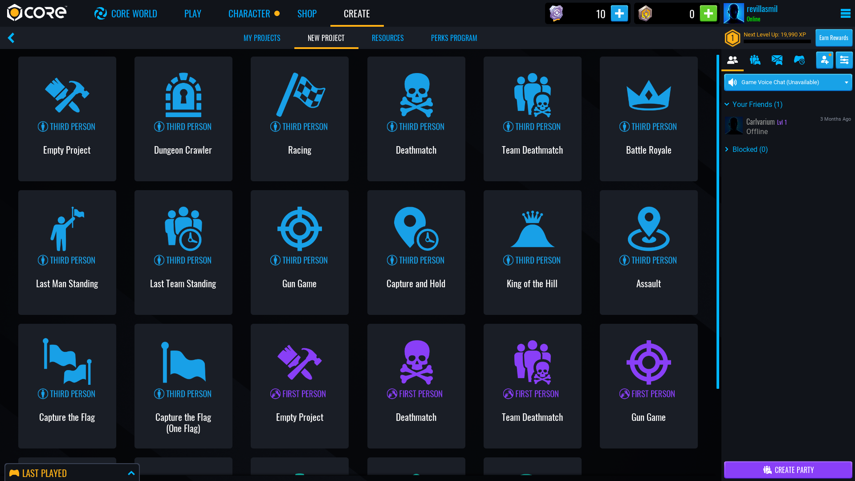

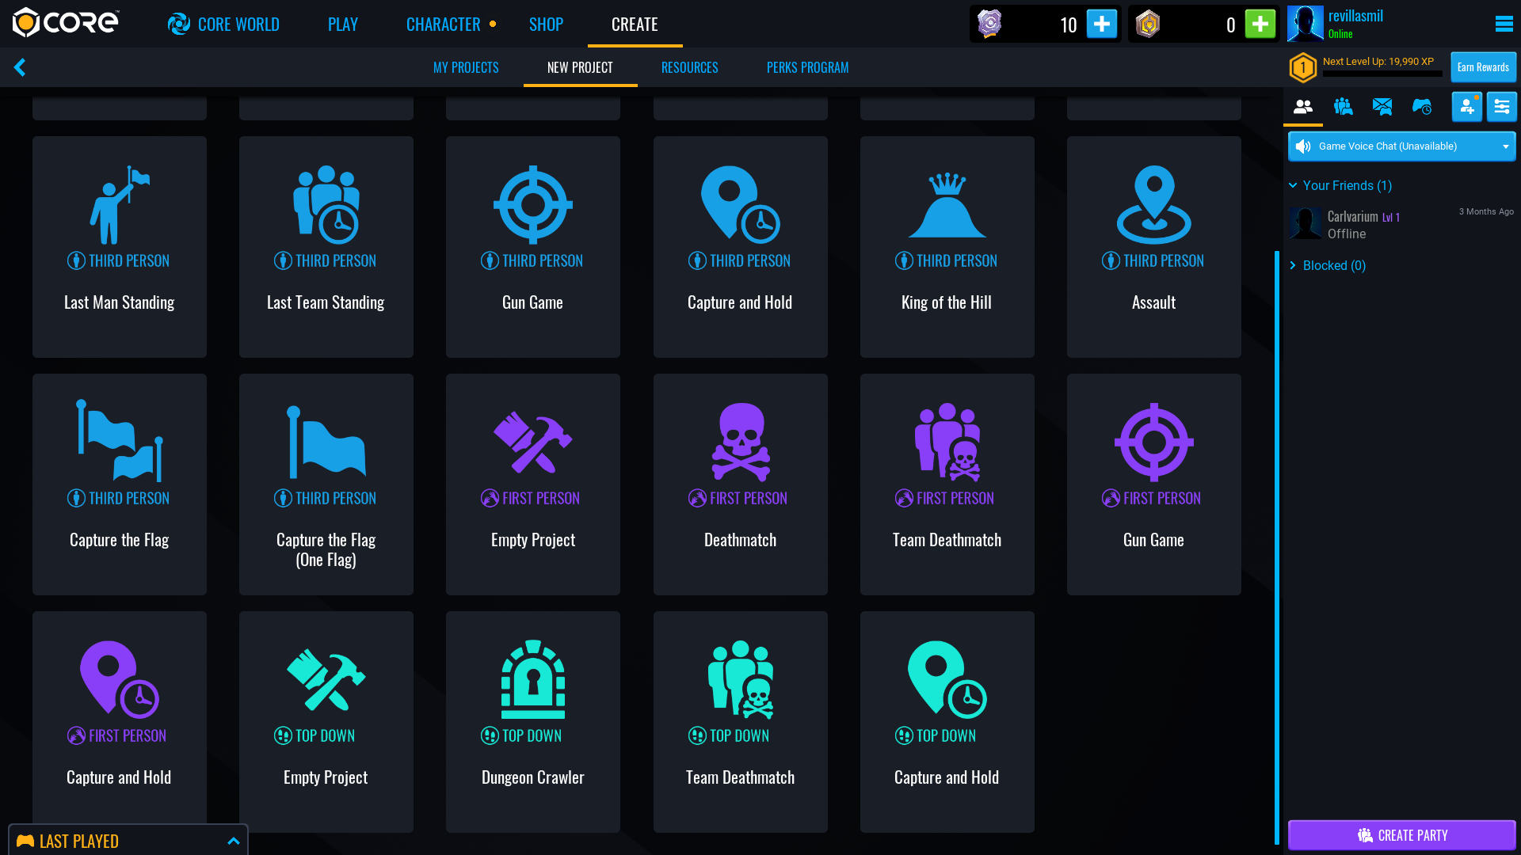

It was made a video capture to show the concept of the core development and the possibilities for developing.

https://www.youtube.com/watch?v=3Cq1ipVYHCM

RE Engine

Another concept that was considered but not taken is the game engine developed by Capcom.

The RE engine is a game engine software developed by Capcom being the the RE the first letters for the full name of the software Reach for the moon showing on the logo.


The engine have a variety of new graphics technique from the VFX for fog, electricity, fire, even able to reach 4K resolution for the textures for both levels and players, even is able to make VR projects.

Between the many projects made on it in the last years have been the next ones listed down below:

- Resident Evil 7: Biohazard (2017)
- Resident Evil 2 (2019)
- Devil May Cry 5 (2019)
- Resident Evil: Resistance (2020)
- Resident Evil 3 (2020)
- Ghosts 'n Goblins Resurrection (2021)
- Monster Hunter Rise (2021)
- Resident Evil: Village (2021)
- Resident Evil Re:Verse (2021)

Was made screen captures of the gameplay that includes a "photo mode" that help on capture the reach of the graphic quality of the textures and the visual.

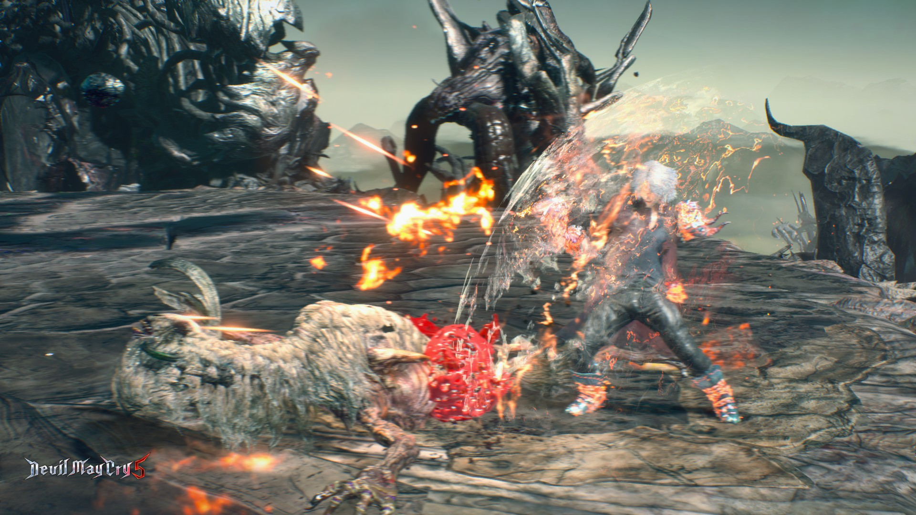

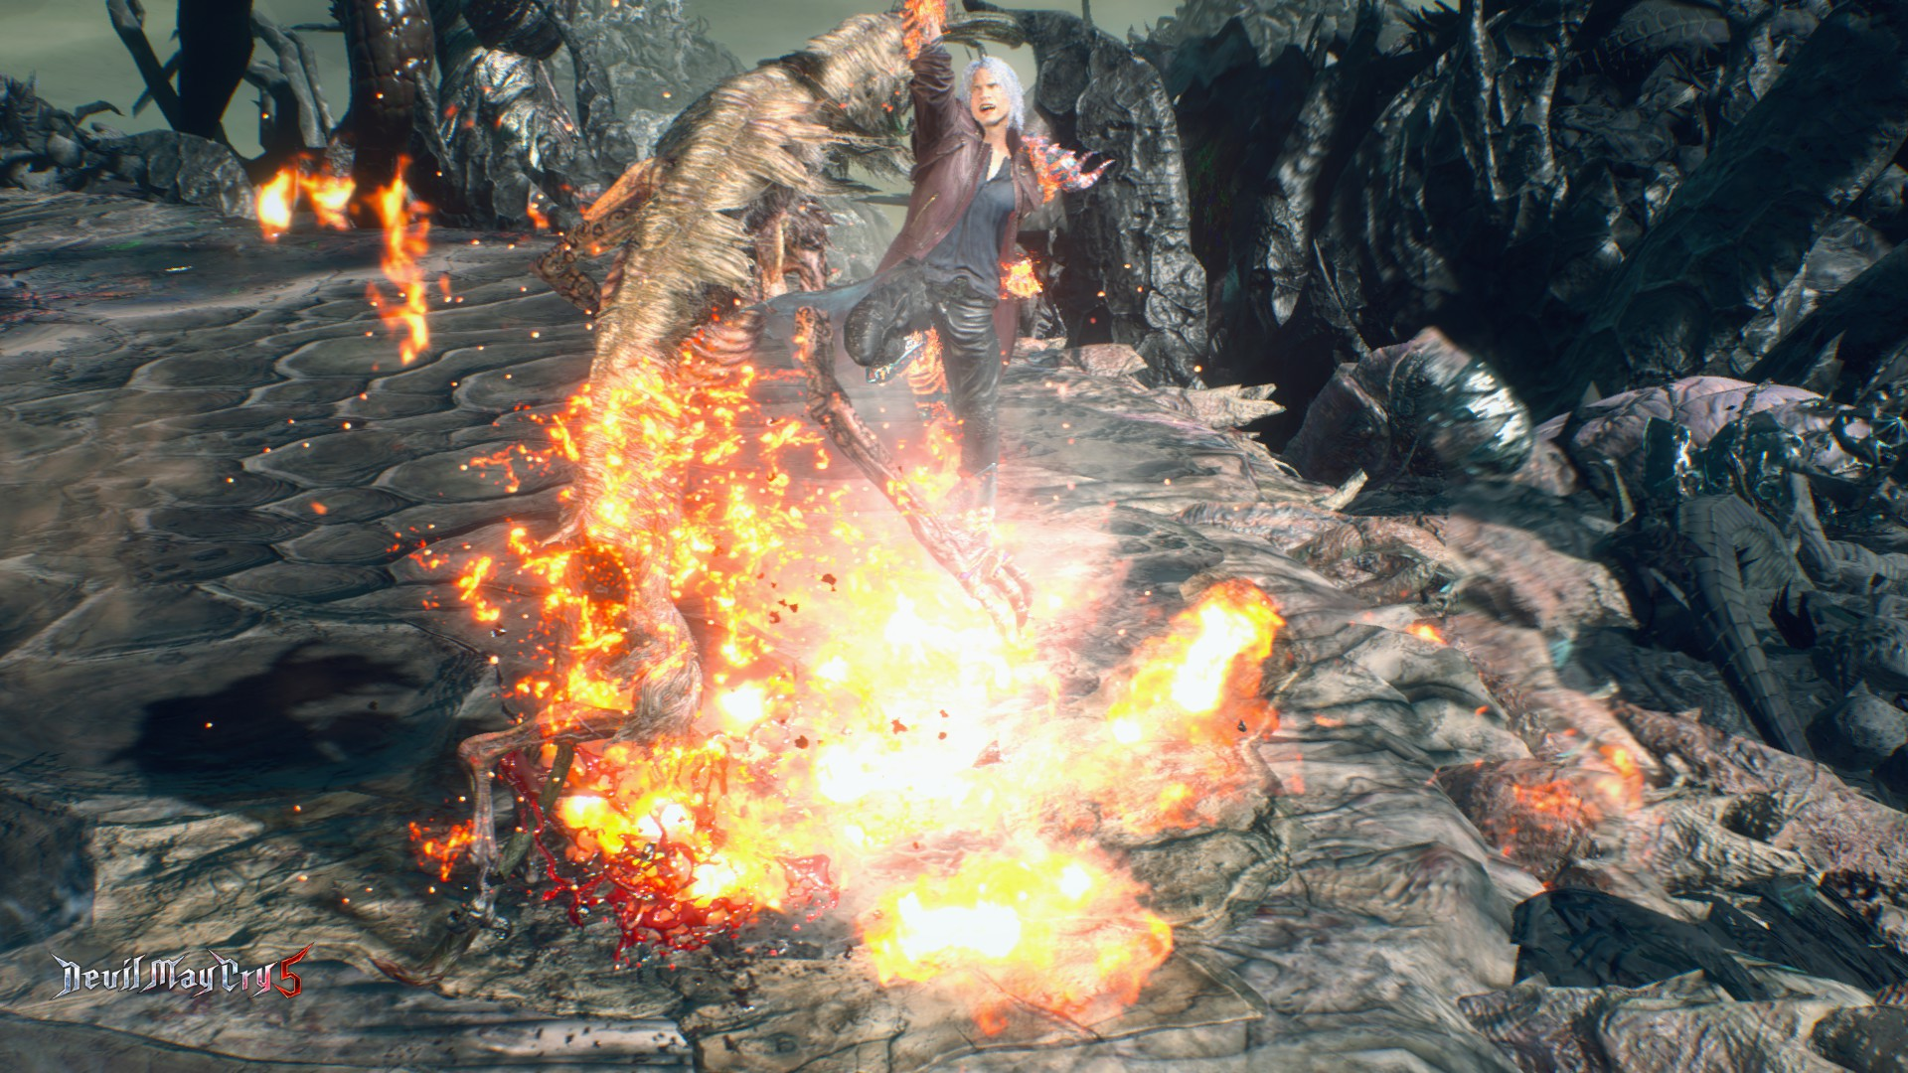

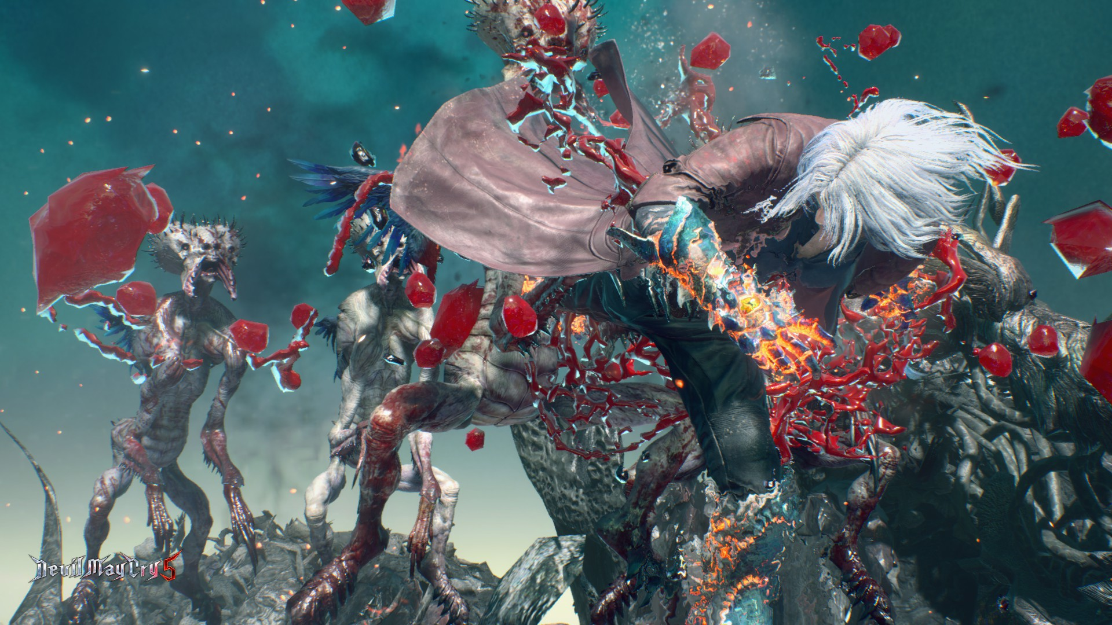
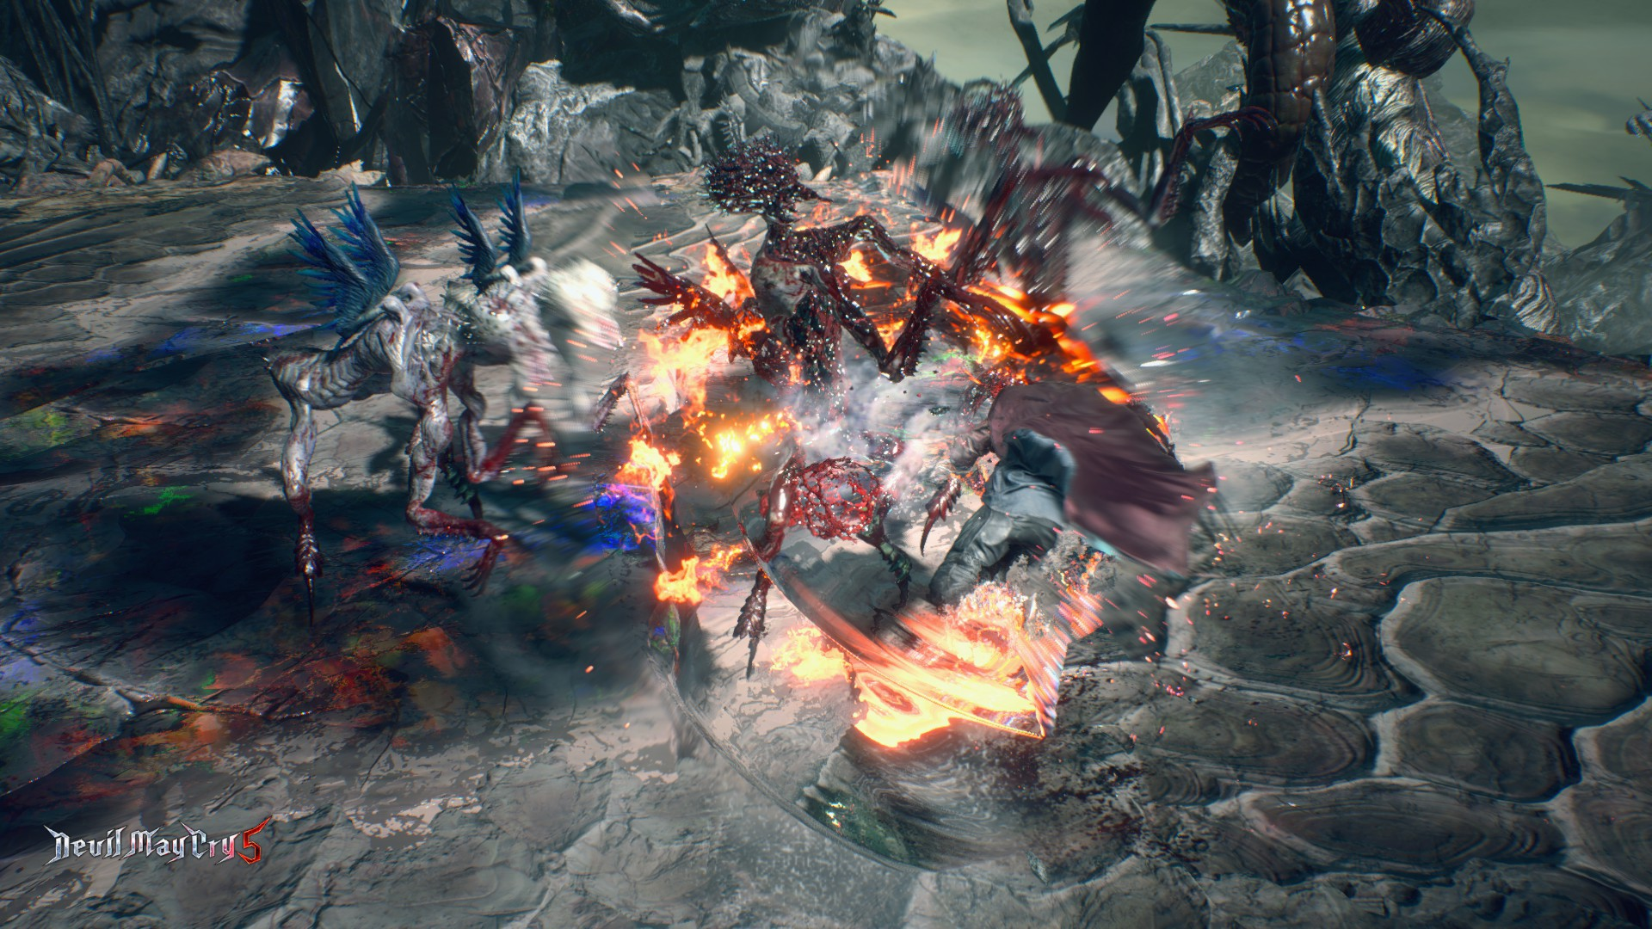
Same way will be links for videos of gameplays to show the performance and the details of both control and graphic quality.

https://youtu.be/CRVRJIVoAhk

https://youtu.be/m_czyQuod-0

The potential is high with the proper ideas however the only setback is the engine being so far exclusively for Capcom developers so far.

